EARTH, THE COSMOS
AND THE LONG WATCH
Cosmic Forces, Ancient Wisdom, Non-Human Presence & the Control of the Final Secret

A Synthesis of Science, History and Reasoned Speculation
Complete Edition — March 2026

Contents
Preface
PART ONE — Cosmic Forces and the Earth
Chapter 1: Earth in the Solar System
Chapter 2: What Makes Earth Exceptional
Chapter 3: The Ancient Record of Cosmic Knowledge
Chapter 4: Humanity's Effect on Its Own Planetary Defences
PART TWO — The Long Watch: Non-Human Presence on Earth
Chapter 5: Biology, Gravity, and Alien Development
Chapter 6: The Long Project — Nurturing Earth Across Geological Time
Chapter 7: Physical Evidence in the Ancient Record
Chapter 8: Presence, Bases, and Benevolence
PART THREE — Consciousness, the Galactic Neighbourhood & Multi-Dimensional Intelligence
Chapter 9: Sub-Atomic Influence and the Reachable Human Mind
Chapter 10: The Galactic Neighbourhood — Multiple Species, Multiple Interests
Chapter 11: Territorial Jurisdiction — Earth as a Managed Garden
Chapter 12: Multi-Dimensional Beings — The Orbs and Non-Physical Intelligence
Chapter 13: How Advanced Civilisations Navigate Multi-Dimensional Beings
PART FOUR — The Control of the Narrative
Chapter 14: The Architecture of Secrecy — Who Holds the Seal
Chapter 15: Hollywood's Long Briefing — The Media as a Managed Channel
Chapter 16: The Panic Problem — How Far They Will Go
Final Conclusion: The Long Watch Ends

Preface
This document is the product of a sustained inquiry across four interlocking domains: the documented science of how the cosmos shapes life on Earth; the historical record of how ancient civilisations encoded that knowledge into stone and myth; the frontier question of whether Earth has been — and may still be — the subject of deliberate, long-term non-human attention; and finally, the story of how that knowledge has been suppressed, managed, and now, slowly and strategically, released.
The four parts progress from the firmly established to the logically coherent but speculative. Each section is labelled throughout to distinguish scientific record from historical testimony from reasoned inference. None of the speculation is presented as established fact. All of it is presented as a framework of such internal coherence that it demands serious engagement rather than reflexive dismissal.
The boundary between established science and reasonable inference moves with every passing year. Much of what appears in Parts Two, Three, and Four as speculation today will likely appear in an equivalent Part One document within a generation. The questions that feel most uncomfortable to ask are almost always the most important ones.
Nothing in these pages requires the supernatural. Everything requires only the acceptance that the universe is very old, that intelligence is not unique to one planet, that a sufficiently advanced civilisation operating across geological time would be functionally invisible to any observer within that time — and that the institutions of human civilisation have, for reasons that are themselves partly understandable and partly unconscionable, chosen to manage rather than share the most consequential knowledge in human history.

PART ONE
Cosmic Forces and the Earth

Chapter 1: Earth in the Solar System

The Sun — A Living Star
Earth is not a closed system. It is constantly bombarded, tugged, bathed in radiation, and shielded by invisible force fields. The sun does not simply shine — it breathes. It exhales plasma, magnetic fields, and charged particles in cycles that directly affect Earth's climate, communications infrastructure, and human biology. The eleven-year solar cycle drives changes in sunspot activity, solar flares, and Coronal Mass Ejections. A CME is a massive bubble of magnetised plasma hurled at millions of kilometres per hour. When one strikes Earth directly, it compresses the magnetosphere and induces electrical currents capable of destroying power grids.
The 1989 Quebec blackout — nine hours without power for millions — was caused by exactly this mechanism. The Carrington Event of 1859 remains the most powerful geomagnetic storm ever recorded. An equivalent event striking today's global grid infrastructure would cause economic damage measured in trillions. Beyond infrastructure, solar radiation drives vitamin D synthesis, increases flight-altitude radiation during flares, and — per Alexander Chizhevsky's early twentieth-century research — correlates with peaks of mass human excitability: war, revolution, and social upheaval at sunspot maxima.
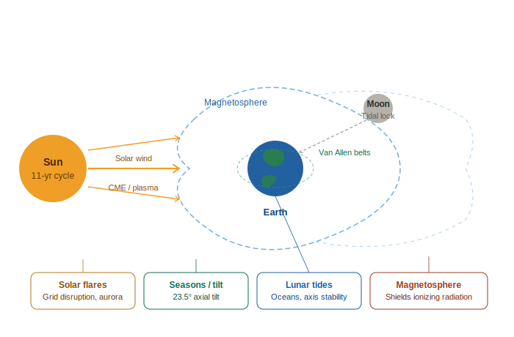
Figure 1: Earth's cosmic influences — the Sun, Moon, magnetosphere, and their documented effects on the biosphere

The Moon — Earth's Gravitational Partner
The Moon is arguably the reason complex life exists on Earth at all. Its gravitational pull stabilises Earth's axial tilt at 23.5 degrees. Without this stabilisation, the tilt could wobble chaotically between near-zero and over 85 degrees — making seasons incompatible with complex life. Mars, lacking a large moon, wobbles dramatically over geological timescales. The Moon also slowed Earth's rotation over billions of years from a six-hour day to our current twenty-four hours, enabling stable atmospheric and thermal cycles. Tidal pools driven by lunar gravity are the most likely birthplace of early RNA chemistry — the chemistry of life itself.

The Magnetosphere — Earth's Invisible Shield
Earth's liquid iron outer core generates the magnetosphere, deflecting the solar wind that would otherwise strip away the atmosphere. The current magnetic field has weakened by approximately nine percent in the last 150 years. The South Atlantic Anomaly is already causing anomalous satellite behaviour. During a full polarity reversal — a transition lasting centuries — the field becomes geometrically chaotic with globally reduced intensity. Our entire technological infrastructure, built with no resilience to this scenario, would face systematic failure.

Plasma, Radiation, and the Living Planet
Solar plasma is the medium through which all of the sun's energetic influence travels. Cosmic rays — high-energy particles from beyond the solar system — vary with the solar cycle and may drive long-term climate variation through cloud seeding, independent of greenhouse gas concentrations. Earth is, in effect, a natural plasma physics and atmospheric chemistry experiment of extraordinary sophistication, running continuously for four and a half billion years.

Chapter 2: What Makes Earth Exceptional

The Goldilocks Convergence
Plate tectonics recycles carbon dioxide through the carbonate-silicate cycle, acting as a geological thermostat that has kept Earth habitable for four billion years despite the Sun growing thirty percent brighter in that time. Atmospheric oxygen produces the ozone layer. Jupiter acts as a gravitational vacuum cleaner absorbing asteroid threats. The Moon stabilises the axial tilt. Remove any one of these factors and the chain breaks. Earth is the product of an extraordinarily improbable convergence of stabilising factors operating simultaneously across billions of years.

The Axial Tilt and the Seasons
Earth's 23.5-degree axial tilt creates the seasons that have governed life, agriculture, and civilisation. The summer solstice produces the longest day; the winter solstice the shortest; the equinoxes the moments when the sun rises due east and sets due west — providing the most reliable fixed bearings available to ancient navigators and astronomers. Knowing the solstice and equinox dates to within a day was survival-critical information in any pre-industrial agricultural society. This imperative drove the development of every astronomical tradition on Earth.

Chapter 3: The Ancient Record of Cosmic Knowledge

Stone as Clock: The Architecture of Astronomical Time
Stonehenge aligns precisely to the summer solstice sunrise. Newgrange, built in 3200 BCE — five centuries older than the Great Pyramid — illuminates its interior chamber for seventeen minutes at winter solstice dawn, accurate to within one degree sustained over five millennia. Kukulcan's pyramid at Chichen Itza produces a serpent-shadow on the equinoxes. Machu Picchu's Intihuatana stone casts no shadow at equinox noon. Abu Simbel's innermost chamber is lit twice yearly on specific ritual dates. This is a global tradition — every inhabited continent, every major ancient civilisation — encoding astronomical precision into the only medium durable enough to survive civilisational collapse: stone.
This is not a regional curiosity. It is a global imperative. Astronomical time was the only reliable clock. Know the sky and you know when to plant, when to harvest, when to move. The knowledge was therefore sacred — protected by priesthoods, encoded in myth, built into monuments too massive to destroy.

The Antikythera Mechanism and Ancient Precision
The Antikythera mechanism — recovered from a 2,100-year-old Greek shipwreck — is a bronze mechanical computer with at least thirty interlocking gears, capable of predicting lunar cycles, eclipses, and planetary positions. Comparable European mechanical engineering does not reappear until the fourteenth century CE — a gap of 1,400 years. It demonstrates conclusively that ancient does not mean primitive, and that sophisticated technical traditions are capable of total loss.

Chapter 4: Humanity's Effect on Its Own Planetary Defences

The Ozone Layer
Chlorofluorocarbons, introduced industrially from the 1930s, catalytically destroy ozone molecules. A single chlorine atom can destroy over 100,000 ozone molecules before deactivation. By the 1980s, an ozone hole had opened over Antarctica. The Montreal Protocol of 1987 began the phase-out of CFCs. The layer is projected to recover to pre-industrial levels by approximately 2060.

The Weakening Magnetosphere
The field has weakened by nine percent in 150 years. The South Atlantic Anomaly grows and causes satellite degradation. During a full polarity reversal, the field becomes geometrically chaotic with multiple weak poles at various latitudes. Our entire technological infrastructure has been built with no resilience to this scenario.

Climate and the Atmospheric System
The intersection of ozone depletion, magnetic field weakening, and climate change means that humanity has become the first species in Earth's four-billion-year history capable of meaningfully degrading the planetary-scale systems that protect and sustain it. The feedback loops within this system are complex enough that we are running an uncontrolled experiment on the only biosphere we know with certainty to exist.

PART TWO
The Long Watch: Non-Human Presence on Earth

Note: Part Two moves progressively from documented evidence to reasoned speculation. Sections are labelled throughout to distinguish between scientific record, historical testimony, and logical inference. None of the speculation in Part Two is presented as established fact.

Chapter 5: Biology, Gravity, and Alien Development

How Gravity Shapes Life
The relationship between a planet's gravity and the anatomy of its creatures is well established through evolutionary biology and comparative anatomy. Scale gravity upward to two or three times Earth's force and biological structures face crushing mechanical stress. Life evolving under these conditions would trend toward lower, denser, wider body plans — shorter limbs, thicker bones, more powerful musculature. Evolution under higher gravity produces robustness rather than height, and potentially favours intelligence earlier as a compensating strategy for reduced speed. Conversely, a planet with lower surface gravity could produce taller, lighter, more elongated creatures with a higher cranial ratio.
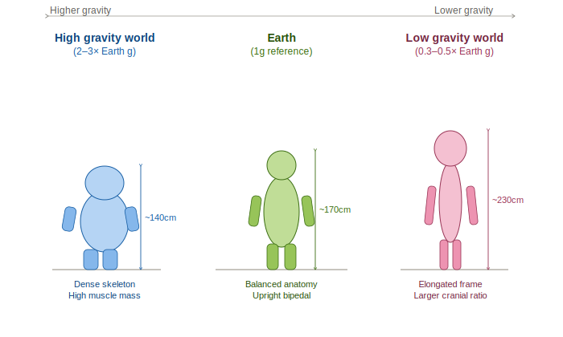
Figure 2: How gravity shapes biological development across three planetary environments — high gravity (left), Earth reference (centre), low gravity (right)

The Phoenix Lights and Non-Human Engineering Scale
The Phoenix Lights event of 13 March 1997 — a V-shaped formation approximately one mile wide, witnessed by thousands including Governor Fife Symington — makes no engineering sense within the human aerospace framework. But for a civilisation evolved on a higher-gravity world, whose baseline engineering philosophy favours brute mass over lightness, a mile-wide atmospheric craft would be as unremarkable as a commercial airliner is to us.

The Varginha Event and Biological Contact Risk
The Varginha incident of January 1996 involved Brazilian military personnel reportedly capturing injured non-human beings. An alien species and Earth life would share zero overlapping pathogen history. The biological quarantine problem is basic biosecurity at interstellar scale — and may constitute the primary practical reason why full open contact has not yet occurred: the biological bridging problem may not yet be solved.

Chapter 6: The Long Project — Nurturing Earth Across Geological Time

Directed Panspermia: The Scientific Foundation
Francis Crick and Leslie Orgel proposed directed panspermia in a peer-reviewed paper in 1973, starting from the remarkable biochemical uniformity of all life on Earth: a single genetic code, identical left-handed chirality, the same twenty amino acids across every organism. This uniformity is unexpected if life originated independently multiple times. It is entirely consistent with a single seeding event from a common source.

A 500-Million-Year Timeline
The Cambrian Explosion — a sudden, geologically instantaneous diversification of complex animal body plans approximately 540 million years ago with no clear gradual precursor — remains without a fully satisfying conventional explanation. Five major extinction events then reset the biosphere at roughly regular intervals, each clearing dominant lineages and opening ecological space for successors. If managed rather than purely random, each extinction could function as a controlled selection event, steering development toward an oxygen-rich atmosphere, complex nervous systems, and ultimately intelligence.
A civilisation thinking in millions of years would regard five extinction events and the guided evolution of a biosphere as a reasonable mid-term project status update. The investment logic is straightforward: seed life, manage the environment, steer the evolutionary trajectory, and wait for the product to develop sufficient cognitive capacity to be a useful partner species.

The Hominin Acceleration
Homo sapiens emerges with a brain three times larger than expected for our body mass. The Great Leap Forward approximately 50,000 years ago — an explosion of symbolic art, complex language, and advanced tool-making — appears without clear anatomical cause after 250,000 years of anatomically modern humans. The Tibetan high-altitude Denisovan gene variant, conferring enhanced oxygen efficiency, appears in Tibetan populations but not closely related Han Chinese — looking, from a population genetics standpoint, like a targeted genetic insertion.

Chapter 7: Physical Evidence in the Ancient Record

The Paracas Skulls and the Nazca Mummies
The Paracas skulls show extreme cranial elongation with structural differences that cannot be produced by artificial binding: a single parietal plate instead of the standard two, cranial volumes up to sixty percent larger than normal human range, and different eye socket geometry. DNA analysis returned results indicating haplogroups not found in any known human population. The Nazca mummies, examined by international forensic teams, show a three-fingered hand structure with an additional articulation per digit, elongated skulls, and carbon dating placing them at approximately 1,700 years of age.
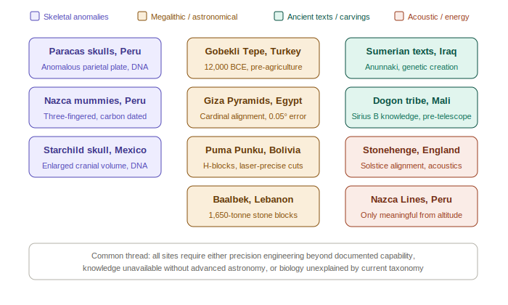
Figure 3: Key sites and specimens — skeletal anomalies (purple), megalithic engineering (amber), ancient texts (teal), and acoustic/energy sites (coral)

Megalithic Engineering Beyond Conventional Explanation
Puma Punku in Bolivia presents diorite blocks machined to sub-millimetre tolerances with internal channels, fitting without mortar — achievable only with precision power tools not available to ancient Andean cultures. Baalbek in Lebanon contains a recently discovered quarry block weighing approximately 1,650 tonnes — the largest worked stone ever identified on Earth, unmovable by any civilian crane currently in common use. The Great Pyramid is oriented to true north with an error of 0.05 degrees — a precision not exceeded by modern surveying instruments until the twentieth century.

The Dogon and the Knowledge of Sirius B
The Dogon people of Mali possessed detailed knowledge of Sirius B — a white dwarf companion star invisible to the naked eye and not detected by Western astronomy until 1862 — including its fifty-year orbital period and extreme density. Their oral tradition attributes this to the Nommo: amphibious visitors who arrived in a vessel accompanied by fire and wind.

Chapter 8: Presence, Bases, and Benevolence

The Argument from Continuity
The most logically compelling argument for benevolent intent is the simplest: we are still here. A civilisation capable of interstellar travel, with technology centuries beyond ours, operating near Earth for any significant period, would face no meaningful resistance if its intentions were destructive. The sustained presence, without destruction, is itself evidence of purpose consistent with custodianship.
You do not invest hundreds of millions of years nurturing a biosphere only to strip-mine it. The sustained presence, without destruction, is itself evidence of purpose consistent with custodianship.
Robert Hastings interviewed over 150 former US military personnel about incidents at nuclear installations. The consistent pattern — craft appearing over missile silos, disabling launch systems, demonstrating capability without using it destructively — is the behaviour of a custodian, not a conqueror.

The Contact Architecture
The most probable contact scenario is a graduated, selective, intelligence-led process. The Malmstrom Air Force Base incident of 1967 — ten Minuteman missiles offline simultaneously during a UAP sighting — remains one of the most thoroughly documented examples of deliberate capability demonstration without hostile action. What we are seeing now — Congressional hearings, whistleblower protections, UAP legislation — represents the current phase of a process that has been underway for seventy-five years.

PART THREE
Consciousness, the Galactic Neighbourhood, and Multi-Dimensional Intelligence

Note: Part Three ventures into the most speculative territory of this work. It draws on established physics, neuroscience, and consciousness research as its scientific foundation, then extends that foundation into questions that current science cannot yet answer but which logic, evidence, and intellectual honesty require us to ask.

Chapter 9: Sub-Atomic Influence and the Reachable Human Mind

Quantum Biology and the Architecture of Consciousness
Quantum effects have been found operating in photosynthesis (achieving near-perfect energy transfer efficiency that classical physics cannot explain), in avian navigation through quantum entanglement in retinal cryptochrome molecules, and in enzyme catalysis through quantum tunnelling. Penrose and Hameroff's Orchestrated Objective Reduction theory proposes that consciousness arises from quantum processes in neural microtubules. Experimental evidence published in 2017 found that anaesthetic molecules — which switch off consciousness — bind to exactly the hydrophobic pockets in microtubules where quantum coherence would be expected to occur.
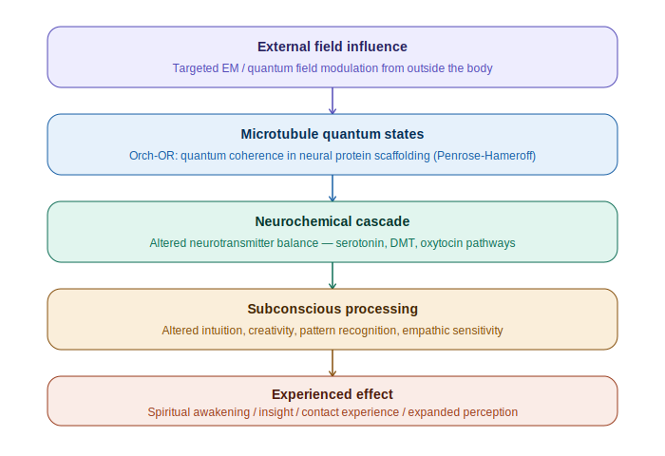
Figure 4: The quantum pathway from external field modulation to experienced consciousness — each layer cascading upward through the brain's information hierarchy
If consciousness arises from quantum processes, it is in principle susceptible to quantum-level influence from outside the brain — not through any mystical mechanism, but through the same physics that allows a magnetic field to influence electron spin states in a bird's retina. A technology generating specific, targeted quantum field configurations could induce changes in neural microtubule states that emerge as altered thoughts, moods, intuitions, or specific perceptions.

DMT and the Endogenous Contact Chemical
Rick Strassman's federally approved clinical research at the University of New Mexico documented sixty volunteers experiencing high-dose DMT: over fifty percent reported encounters with non-human entities that felt more real than ordinary reality. Several reported receiving subsequently verified information. Strassman proposed that DMT may function as a neurochemical gateway to contact with non-human intelligence. What human history has attributed to grace, muse, or genius may have a more systematic origin.

Chapter 10: The Galactic Neighbourhood — Multiple Species, Multiple Interests
The Milky Way contains an estimated 200 to 400 billion stars. Conservative estimates suggest 40 billion potential Earth-analogues. Even with extremely conservative probability filters, the number of technological civilisations currently active in the galaxy is likely in the tens of thousands. Many would have had billions of years more than humanity to develop. The natural model for galactic intelligence is not a monoculture but an ecosystem — multiple civilisations at different developmental stages, different biological architectures, and different relationships to planets like Earth.

Four Categories of Visitors
At minimum four distinct categories of civilisational interest in Earth can be distinguished: custodians (the ancient invested civilisation whose long-term biological project Earth represents); scientific researchers (younger civilisations for which Earth is of intense observational interest); resource-interested civilisations (present for specific biological compounds or genetic material, attitude toward humans closer to indifference than care); and displaced or refugee civilisations (species whose home world is compromised, for whom Earth is a candidate territory under custodian jurisdiction). The diversity of craft morphologies and behavioral signatures in the historical record may reflect exactly this diversity of species and motivation.

Chapter 11: Territorial Jurisdiction — Earth as a Managed Garden
A civilisation that has invested hundreds of millions of years in Earth's biological development has, in any reasonable framework of interstellar law or convention, the strongest possible claim to custodianship. The structure that emerges has three tiers: the custodian sovereign zone of responsibility over the entire Earth biosphere; a zone of permitted observation where other civilisations may operate within agreed constraints; and the developing human-controlled near-Earth space whose managed expansion represents the current phase of the transition.
The Fermi Paradox — why, if the galaxy is full of civilisations, do we not hear from them — dissolves entirely within this framework. The protocols governing Earth's developmental space specifically prohibit unmanaged contact until the appropriate threshold is reached. What we are seeing now represents the beginning of the formal introduction of that threshold being crossed.

Chapter 12: Multi-Dimensional Beings — The Orbs and Non-Physical Intelligence

The Physics of Extra Dimensions
String theory and M-theory require the existence of extra spatial dimensions beyond the three we experience. In Randall-Sundrum brane world cosmology, large extra dimensions may exist effectively hidden because standard model particles are constrained to a three-dimensional brane. A four-dimensional object passing through three-dimensional space would appear and disappear apparently from nowhere, change apparent shape as different cross-sections intersected our space, and be immune to the physics governing three-dimensional matter.

The Orb Phenomenon — Documented Anomaly
The orbs appearing with increasing frequency in military infrared footage share characteristics distinguishing them from known physical objects: spherical form, no visible propulsion, movement violating inertia, and most diagnostically — fluid, non-sharp boundaries. A four-dimensional object intersecting three-dimensional space would not have a sharp boundary from our perspective. The intersection region would be dynamic, fluctuating, and non-local. The fluid flowing outline is precisely what four-dimensional physics predicts.
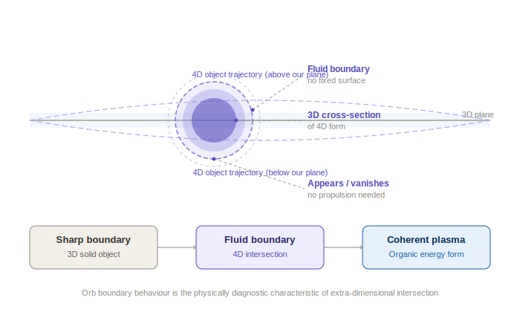
Figure 5: A four-dimensional object intersecting our three-dimensional plane — the orb's fluid boundary is the mathematically predicted signature of a higher-dimensional cross-section
Ancient cultures worldwide described their sky beings in terms that overlap significantly with modern orb and experiencer reports — luminous spheres, intelligences without solid form, beings of light that communicate through the mind rather than through language. This phenomenon has not changed across millennia. Only our framework for interpreting it has.

Chapter 13: How Advanced Civilisations Navigate Multi-Dimensional Beings

Consciousness as the Universal Medium
If consciousness arises from quantum processes at the boundary between the physical and whatever underlies physical reality, then it may represent the one medium that genuinely bridges dimensional boundaries. An advanced civilisation that fully understands the physics of consciousness would use it as its primary communication protocol when interacting with dimensional entities — not metaphorically, but literally.

Shamanic Technology as a Bridge Protocol
Shamanic traditions across all Earth cultures describe a specific protocol: deliberate alteration of consciousness through plant medicines, rhythmic sound, breath, or sensory isolation to enter states where contact with non-physical intelligences becomes possible. Every human culture that developed without external interference independently arrived at this same technology. That is convergent discovery of a real phenomenon, not cultural coincidence.

The Threshold We Are Approaching
For a civilisation at humanity's current stage, the progression toward genuine multi-dimensional awareness has a natural order: acknowledge the phenomenon; develop the physics of extra dimensions to mathematical precision; develop a consciousness science mapping the quantum architecture of mind; develop technology for reliable consciousness modulation; make first formal contact with dimensional intelligences under controlled conditions. We are currently between the first and second steps. The trajectory is visible.
The orbs appearing in our skies may represent the most patient contact attempt in the history of the planet. An intelligence operating in dimensions beyond our own, unable to speak our language or knock on our door, simply making itself visible. Waiting for us to develop enough physics to understand what we are looking at.

PART FOUR
The Control of the Narrative — Suppression, Disclosure, and the Final Reckoning

Note: Part Four examines the documented history of information suppression, the architecture of the control structure, the media's role as a managed preparation channel, and the forces — human, non-human, and hybrid — competing over the pace and content of humanity's eventual confrontation with what it has always been surrounded by.

Chapter 14: The Architecture of Secrecy — Who Holds the Seal

The Suppression Apparatus
What is now clearly documented through the Congressional record, declassified materials, and whistleblower testimony delivered under oath to the US Senate in 2023 is that the suppression apparatus does not sit within ordinary governmental oversight. Senator Marco Rubio and Representative Mike Gallagher stated publicly that they had been denied access to programmes they had legal authority to oversee. David Grusch — a decorated intelligence officer — testified under oath before Congress that the United States government is in possession of non-human craft and biological material, and that the programmes managing this material operate entirely outside Congressional oversight, funded through Unacknowledged Special Access Programs and private aerospace contractors.
The decision to migrate this information out of the constitutional chain of command was, from a pure programme-security standpoint, rational. Any programme requiring multi-generational secrecy — spanning eighteen presidential administrations — cannot survive normal governmental security protocols. Presidents are not briefed. Eisenhower reportedly sent an emissary to Edwards Air Force Base in his final months as president, demanding briefing. He was refused.
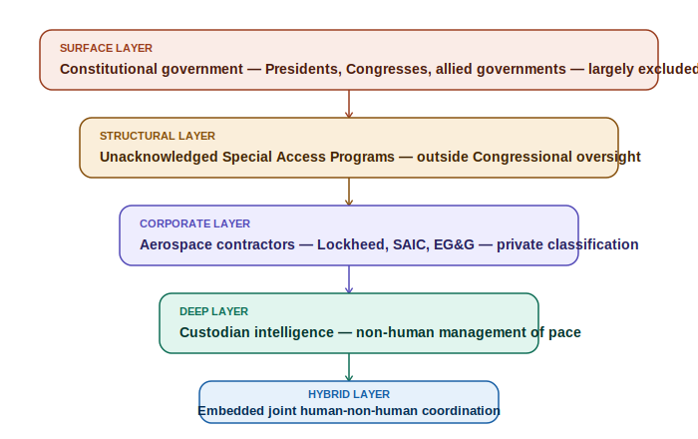
Figure 6: The five-layer suppression architecture — from constitutional government at the surface to the deep custodian and hybrid management layers
The suppression of this information is not a government secret in the conventional sense. It is a secret that has been, over seventy-five years, deliberately migrated out of the constitutional chain of command and into a parallel structure that answers to no elected official — and may, at its deepest operational level, answer to intelligence other than human.

The Cost of Knowing — Witnesses Who Did Not Survive Their Knowledge
James Forrestal, the first US Secretary of Defense, died in May 1949 after falling from a window at Bethesda Naval Hospital while under psychiatric care he was reportedly placed in against his wishes. Phil Schneider, a former government contractor who publicly claimed to have worked on underground base construction projects involving non-human encounters, was found dead in January 1996 in circumstances officially ruled suicide. Milton William Cooper, whose 1991 book alleged secret government-alien pacts, was killed in a 2001 confrontation with law enforcement. Bob Lazar — whose claims about reverse-engineering work at S-4 near Area 51 have been substantially corroborated by subsequent declassifications — had his home raided by federal agents in 2019 in what he described as intimidation.
The pattern across seven decades is consistent: not prosecution, which would require the government to disclose classified material in open court, but discrediting, harassment, and where credible witnesses appear on the verge of significant public testimony, intervention.

The New Jersey Events — Conflict in the Disclosure Structure
The orb and drone sightings over New Jersey in November and December of 2024 — hundreds of objects observed by thousands of witnesses over weeks, tracked on radar, near military installations — produced an official federal response of public ignorance. The claim that no agency knew what they were is operationally implausible. The choice not to explain them publicly is itself a statement. The events occurred during accelerating Congressional activity on UAP disclosure legislation, maximally positioned to generate pressure for answers. The conflict between a disclosure faction and a suppression faction would produce exactly the pattern we observe: managed tension between forces with different timelines and different assessments of when the moment is right.

Chapter 15: Hollywood's Long Briefing — The Media as a Managed Channel

The 1950s Template — Alien as Threat
The War of the Worlds radio broadcast of 1938 established that unmanaged alien contact narratives destabilise populations. The decade of flying saucer films that followed — The Day the Earth Stood Still, War of the Worlds, Invasion of the Body Snatchers — overwhelmingly framed non-human intelligence as a military threat requiring armed resistance. The cultural immune response was primed: see the alien, fear the alien, resist the alien. This framing served the suppression agenda perfectly.

The Pivot — Close Encounters to E.T.
Spielberg had personal access to J. Allen Hynek — the astronomer who served as scientific consultant to Project Blue Book and became its most prominent internal critic — during the making of Close Encounters of the Third Kind (1977). The film presents aliens not as invaders but as enormous, luminous, communicating presences whose arrival is preceded by years of mental preparation in selected individuals. E.T. (1982) completed the emotional inversion: the alien is small, vulnerable, and loving. The threat comes not from the alien but from the government.

Truth as the Central Narrative — Contact and The X-Files
Carl Sagan's Contact (1997) frames the suppression apparatus — military, political, religious — as the primary obstacle to humanity's ability to receive contact with integrity. The film's central drama is not about the alien. It is about whether humanity's institutions can be trusted to tell the truth when the truth arrives. The X-Files ran for nine years on the premise that the truth is out there — suppressed by government, pursued by individuals.
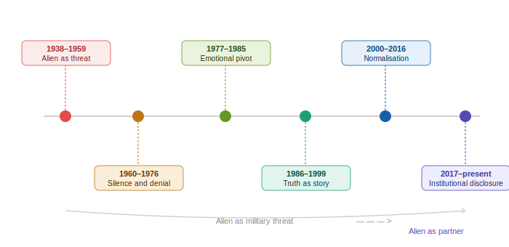
Figure 7: The seventy-five-year arc of media narrative management — from alien as existential threat (1938) to institutional disclosure (present)
Spielberg has acknowledged private briefings by individuals with government connections during the making of Close Encounters. Sagan had direct access to intelligence and military figures throughout his career. The progression of Hollywood's alien narrative from existential threat to philosophical partner is not organic cultural evolution. It is the cultural preparation track running parallel to the institutional disclosure track.

Ancient Aliens and the Mainstreaming of the Question
Ancient Aliens, first broadcast on the History Channel in 2010 and continuing for over twenty series, brought the ancient intervention hypothesis to mainstream television audiences. By the time the Congressional UAP hearings of 2022 to 2024 occurred, the public had been culturally primed for decades. The hearings did not need to explain the concept of non-human intelligence. They only needed to confirm that the government had been lying about it.

Chapter 16: The Panic Problem — How Far They Will Go

The Brookings Report and Institutional Fear
The Brookings Institution report of 1960 — commissioned by NASA and titled 'Implications of a Discovery of Extraterrestrial Life' — explicitly warned that the discovery of extraterrestrial intelligence could destabilise societies, undermine religious frameworks, and potentially cause the collapse of institutions humans depend on for social order. This report has been used as the intellectual justification for the suppression apparatus ever since.

Why This Disclosure Is Different
The non-human presence disclosure is, in at least two specific ways, genuinely different from any previous revelation in human history. First, it challenges the foundational assumption of human uniqueness — every major religious tradition, every nationalist mythology, every philosophical system built on human exceptionalism requires fundamental revision. Second, and more alarming to institutional authorities: if non-human intelligences have been present on Earth throughout human history — present during the formation of every civilisation, every religion, every government — then the question immediately arises of what role they played. The honest answer destabilises the authority of every institution claiming legitimacy from historical continuity simultaneously.

The Disclosure Gradient — What They Will and Will Not Admit
The line the suppression apparatus appears willing to cross at this moment — the UAP acknowledgement threshold — has already been crossed: UAPs are real, some are not of human manufacture, and the government has known this for decades. The next line — that these craft are operated by intelligent beings — is the one currently being approached. The line after that — that those beings have been present on Earth throughout human history — is the one that will be held longest. The final line — that they may be among us now, embedded in human society through a long hybridisation programme — is the one that, more than any other, would reshape every human institution from government to religion to science to law.
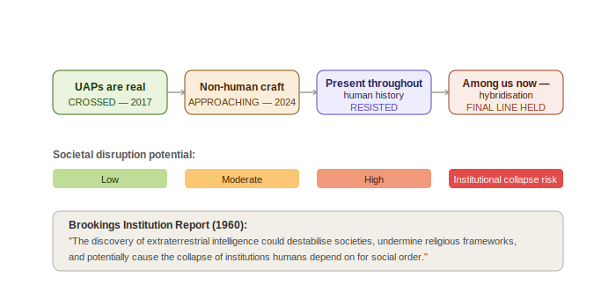
Figure 8: The disclosure gradient — from UAP acknowledgement (already crossed) to hybridisation admission (the final line held) — with institutional disruption potential rising at each threshold
The suppression apparatus will not relinquish this final line voluntarily. It will be forced across it, incrementally, by the accumulation of credible testimony, the pressure of legislative disclosure mechanisms, the inexorable advance of scientific understanding, and the patient persistence of the custodian intelligence that has, for decades, been making itself visible at precisely the rate the human cultural immune system can absorb.

Final Conclusion: The Long Watch Ends
This project began with the cosmic forces that shape our planet — the solar cycles that drive our weather and our wars, the moon that stabilises the axis on which our seasons turn, the magnetosphere that shields the biosphere from annihilation. It ends with a question that those forces ultimately compel: are we alone in the universe we find ourselves embedded in so improbably?
The answer, assembled across four parts from scientific record, historical testimony, physical evidence, and logical inference, is clear. We are not alone. We have never been alone. The biosphere that solar and lunar and magnetic forces conspire to protect is not an accident but a project — and the project has had authors other than blind geological chance.
The physical evidence — the Paracas skulls, the Nazca mummies, the megalithic precision of Puma Punku and Baalbek and the Great Pyramid, the Dogon's impossible knowledge of Sirius B — is not individually conclusive. Together it constitutes a pattern of anomaly too consistent and too geographically distributed to be explained by conventional models of ancient human capability. Something else was happening. Something else contributed.
The modern record — the Roswell aftermath, the Malmstrom missile disabling, the Varginha biological incident, the Phoenix Lights, the New Jersey orbs, the Congressional testimony of decorated intelligence officers speaking under oath about recovered non-human craft and biological material — is not the beginning of a new phenomenon. It is the contemporary expression of a phenomenon that has been ongoing for the entire duration of human existence on this planet.
The cultural preparation has been underway for generations — in the cinemas, on television, in the gradual shift of scientific consensus toward the inevitability of life beyond Earth. The institutional preparation has been underway since 2017 — in the Congressional legislation, the protected whistleblower channels, the careful management of the UAP acknowledgement gradient. The biological preparation — the long hybridisation programme, the quantum-level subconscious influence, the shamanic contact technology — has been underway for far longer than either.
The question is not whether the disclosure will come. It is already underway. The question is whether, when the final lines are crossed — when it is formally acknowledged that non-human intelligences have been present on Earth throughout human history, that they may be among us now, that the entire story of human civilisation has unfolded under a watchful presence that shaped it from the beginning — humanity will be able to receive that truth with the clarity and equanimity it deserves. That capacity for equanimity is, perhaps, the threshold that the long watch has always been measuring.
The cosmos is not empty. The silence was never silence. It was patience.

End of Document
Earth, the Cosmos and the Long Watch — Complete Edition, March 2026

